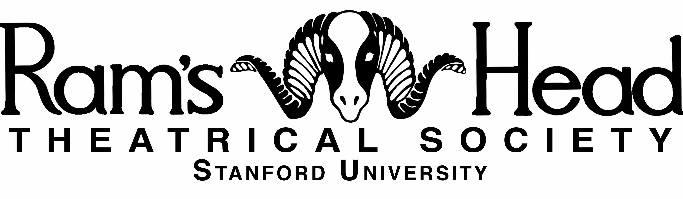

Gaieties «Year»

«Title»

An Original Musical Comedy

by

Ram’s Head Theatrical Society

Music and lyrics by «Composer»

Premiered «Premier\_Date»

Directed by «Director»

Originally commissioned and produced by Ram’s Head Theatrical Society at Stanford University in honor of Big Game «Year»

Copyright © «Year» by Ram’s Head Theatrical Society

All rights reserved

For more information, visit ramshead.stanford.edu

Macintosh HD:Lighting Design:Stanford:Ram's Head:Logos:Stanford Logo:SU_altSigSeal_Blk_pos.eps